Design a java program with one method to put even and odd elements of an array in two separate arrays ,and another method to find the transpose of the matrix by implementing the concept of method overriding

import java.util.Scanner;

class Transpose

{

public void override()

{

System.out.println("To find transpose of a matrix"); //Transpose

int row,column,i,j;

Scanner scan=new Scanner(System.in);

System.out.print("\nEnter the rows of the matrix:");

row=scan.nextInt();

System.out.print("\nEnter the columns of the matrix:");

column=scan.nextInt();

int matrix[][]=new int[row][column];

System.out.println("Enter the matrix elements:");

for(int iter1=0;iter1<row;iter1++)

{

for(int iter2=0;iter2<column;iter2++)

{

matrix[iter1][iter2]=scan.nextInt();

}

}

System.out.println("The matrix is:");

for(i=0;i<row;i++)

{

for(j=0;j<column;j++)

{

System.out.print(matrix[i][j]+"\t");

}

System.out.print("\n");

}

System.out.println("The transpose of the matrix is:");

for(i=0;i<column;i++)

{

for(j=0;j<row;j++)

{

System.out.print(matrix[j][i]+"\t");

}

System.out.print("\n");

}

}

}

public class Evenodd_matrix extends Transpose

{

public void override()

{

super.override();

int size;

Scanner scan=new Scanner(System.in);

System.out.println("\nTo separate even and odd elements"); //Even and odd elements array

System.out.print("Enter the size of the array:");

size=scan.nextInt();

int array[]=new int[size];

System.out.println("Enter the "+size+" elements:");

for(int iter=0;iter<size;iter++)

{

array[iter]=scan.nextInt();

}

int even[]=new int[size];

int odd[]=new int[size];

int iter,iter1=-1,iter2=-1,l=0,m=0;

for(iter=0;iter<size;iter++) //For separating odd and even elements

{

if(array[iter]%2==0)

{

iter1=iter1+1;

l=iter1+1;

even[iter1]=array[iter];

}

else

{

iter2=iter2+1;

m=iter2+1;

odd[iter2]=array[iter];

}

}

System.out.println("Even elements matrix is:"); //Printing Even elements matrix

for(iter1=0;iter1<l;iter1++)

{

System.out.print(even[iter1]+"\t");

}

System.out.println("\nOdd elements matrix is:"); //Printing Odd elements matrix

for(iter2=0;iter2<m;iter2++)

{

System.out.print(odd[iter2]+"\t");

}

}

public static void main(String[] args)

{

Evenodd_matrix obj=new Evenodd_matrix();

obj.override();

}

}

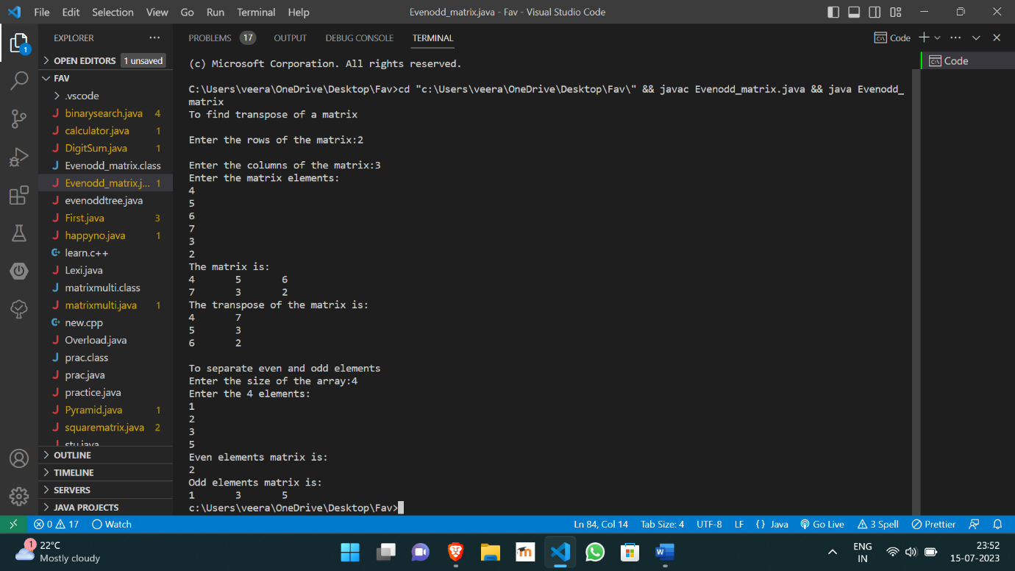

https://github.com/Veeragoutham04/Java_Lab/blob/main/overriding